Inventar A p. 26 no. 6: Missa
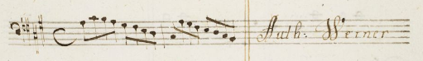

Inventar B p. 110 no. 2: Missa fiduciae in Deum

